**Task A**

**1.**

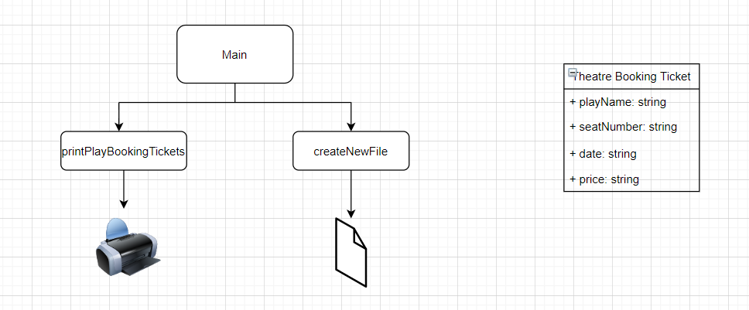

**2.**

Theatre Play Booking Ticket

Play Name: Little Shop of Horrors

Seat Number: D8

Date: 18/08/2020

Price: £10.50

**3.**

* Printing tickets

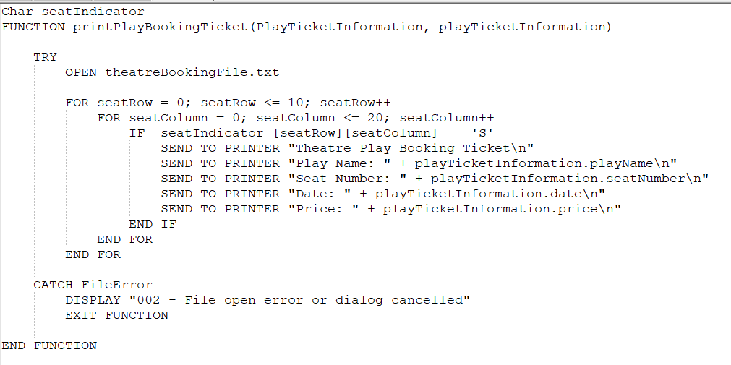

* Create new file

1. Get playName
2. Get date
3. Validate date
4. Print playName and date
5. Print out all the Fs – 10 rows, 20 columns per row

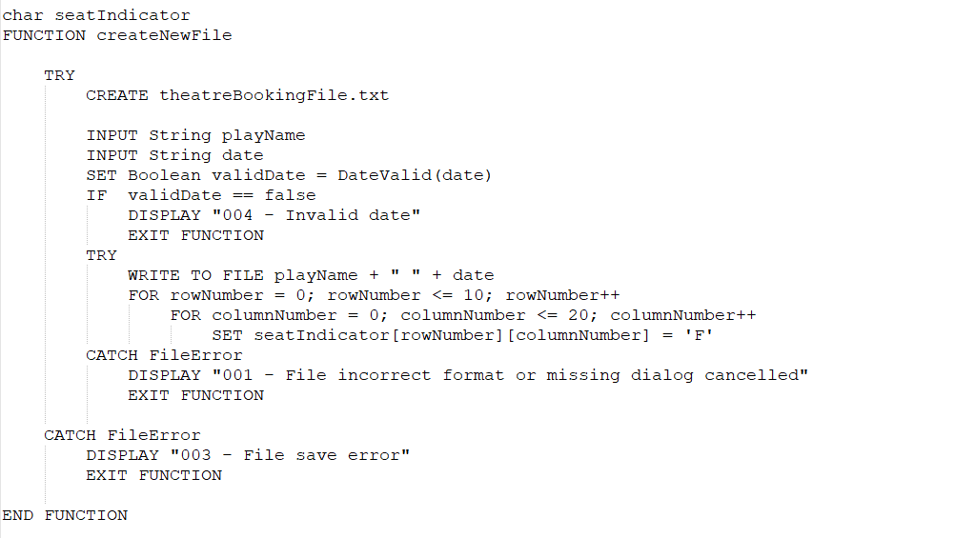

**4.**

All the error codes have been used in the algorithms above.

**5.**

Software design works as a model or a layout for developing a software solution that will meet the specified user requirements. Once the design is agreed upon, it is saved to be revisited when developing the software. If the software design is for a big project, the project can be split into modules to make it easy to work on each requirement of the project also, should the changes to the project be required in future, it would be easy to change the module and not the whole project. Software design is important because it sets a foundation to building the software code.